**Project : Coffee Shop Sales Analysis**

**Table of Contents:**

* [Problem Statement](https://github.com/yogeshkasar778/Sales_insights_of_data_analysis-AtliQ_Hardware/edit/main/README.md#problem-statement-)

* [Data Analysis using MySQL](https://github.com/yogeshkasar778/Sales_insights_of_data_analysis-AtliQ_Hardware/edit/main/README.md" \l "data-analysis-using-mysql-)
* Data Modeling
* [Build Dashboard Or a Report](https://github.com/yogeshkasar778/Sales_insights_of_data_analysis-AtliQ_Hardware/edit/main/README.md#build-dashboard-or-a-report) using Power BI
* [Data Analysis and visualization using Jupyter](https://github.com/yogeshkasar778/Sales_insights_of_data_analysis-AtliQ_Hardware/edit/main/README.md#data-analysis-using-mysql-) Notebook (Python libraries such as pandas, matplotlib, seaborn, plotly and ipywidgets)
* [Tools, Software and Libraries](https://github.com/yogeshkasar778/Sales_insights_of_data_analysis-AtliQ_Hardware/edit/main/README.md#tools-software-and-libraries-)
* [References](https://github.com/yogeshkasar778/Sales_insights_of_data_analysis-AtliQ_Hardware/edit/main/README.md#references-)

**Problem Statement**

**KPI’s REQUIREMENT**

We need to analyze key indicators for our coffee shop sales data to gain insights into our business performance. Specifically, we want to calculate the following metrics:

1. Total Sales Analysis:

* Calculate the total sales for each respective month.
* Determine the month-on-month increase or decrease in sales.
* Calculate the difference in sales between the selected month and the previous month.

1. Average Order Analysis:

* Calculate the number of orders for each respective month.
* Determine the month-on-month increase or decrease in number of orders.
* Calculate the difference in number of orders between the selected month and the previous month.

1. Total Quantity Sold Analysis:

* Calculate the total quantity sold for each respective month.
* Determine the month-on-month increase or decrease in total quantity sold.
* Calculate the difference total quantity sold between the selected month and the previous month.

**CHARTS REQUIREMENT**

We would like to visualize various aspects of our coffee shop sales data to gain insights and understand key trends. We have identified the following requirements for creating charts:

**1. Calendar Heat Map:**

* Implement a calendar heat map that dynamically adjusts based on the selected month from a slicer.
* Each day on the calendar will be color-coded to represent sales volume, with darker shades indicating higher sales.
* Implement tooltips to display detailed metrics (Sales, Orders, Quantity) when hovering over a specific day.

**2. Sales Analysis by Weekdays and Weekends:**

* Segment sales data into weekdays and weekends to analyze performance variations.
* Provide insights into whether sales patterns differ significantly between weekdays and weekends.

**3. Sales Analysis by Store Location:**

* Visualize sales data by different store locations.
* Include month-over-month (MoM) difference metrics based on the selected month in the slicer.
* Highlight MoM sales increase or decrease for each store location to identify trends.

**4. Daily Sales Analysis with Average Line:**

* Display daily sales for the selected month with a line chart.
* Incorporate an average line on the chart to represent the average daily sales.
* Highlight bars exceeding or falling below the average sales to identify exceptional sales days.

**5. Sales Analysis by Product Category:**

* Analyze sales performance across different product categories.
* Provide insights into which product categories contribute the most to overall sales.

**6. Top 10 Products by Sales:**

* Identify and display the top 10 products based on sales volume.
* Allow users to quickly visualize the best-performing products in terms of sales.

**7. Sales Analysis by Days and Hours:**

* Utilize a heat map to visualize sales patterns by days and hours.
* Implement tooltips to display detailed metrics (Sales, Orders, Quantity) when hovering over a specific day-hour.

**Data Analysis using MySQL**

Utilized MySQL for data extraction and calculation of key metrics such as Total Revenue, Average Order Value, Total Pizzas Sold, Total Orders, and Average Pizzas Per Order.

**DATA IMPORT**

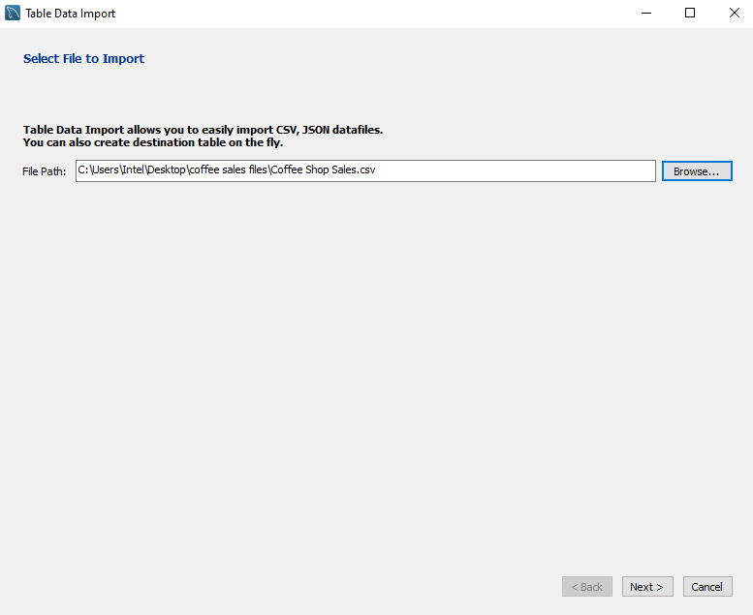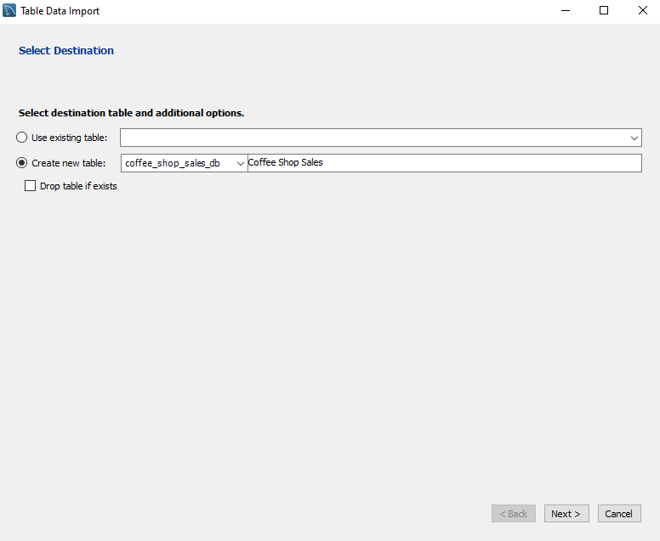

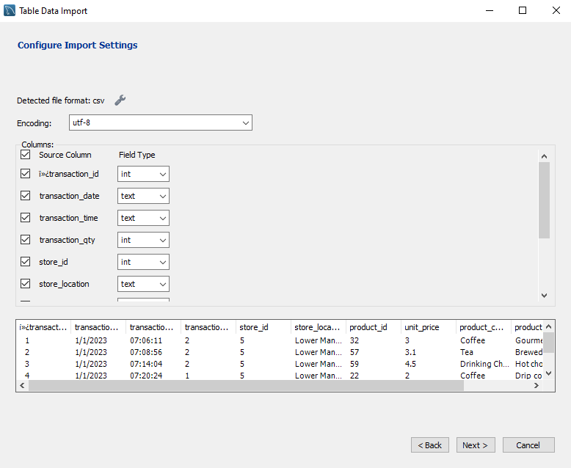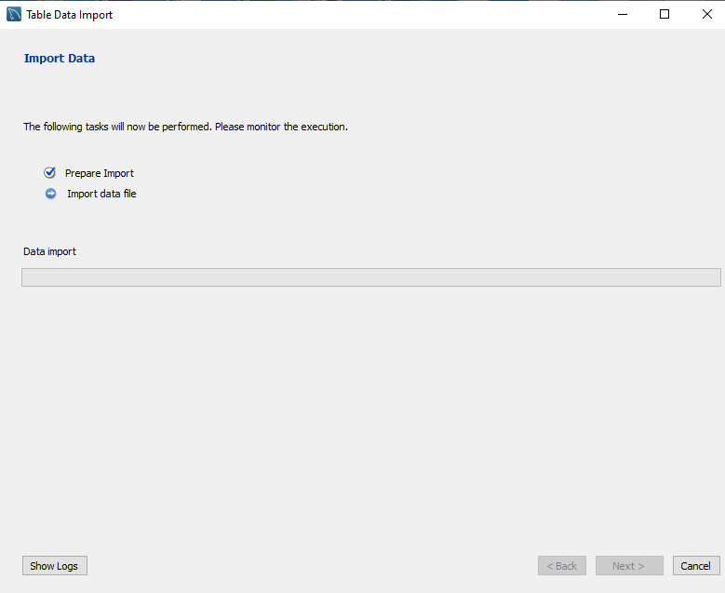

[**Data Analysis using MySQL**](https://github.com/yogeshkasar778/Sales_insights_of_data_analysis-AtliQ_Hardware/edit/main/README.md#data-analysis-using-mysql-)

**CONVERT DATE (transaction_date) COLUMN TO PROPER DATE FORMAT**

UPDATE coffee_shop_sales

SET transaction_date = STR_TO_DATE(transaction_date, '%d-%m-%Y');

**ALTER DATE (transaction_date) COLUMN TO DATE DATA TYPE**

ALTER TABLE coffee_shop_sales

MODIFY COLUMN transaction_date DATE;

**CONVERT TIME (transaction_time) COLUMN TO PROPER DATE FORMAT**

UPDATE coffee_shop_sales

SET transaction_time = STR_TO_DATE(transaction_time, '%H:%i:%s');

**ALTER TIME (transaction_time) COLUMN TO DATE DATA TYPE**

ALTER TABLE coffee_shop_sales

MODIFY COLUMN transaction_time TIME;

**DATA TYPES OF DIFFERENT COLUMNS**

DESCRIBE coffee_shop_sales;

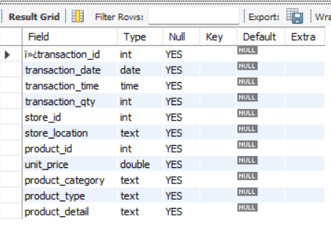

**CHANGE COLUMN NAME `ï»¿transaction_id` to transaction_id**

ALTER TABLE coffee_shop_sales

CHANGE COLUMN `ï»¿transaction_id` transaction_id INT;

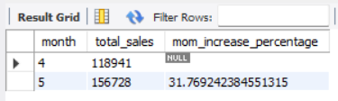

**TOTAL ORDERS**

SELECT COUNT(transaction_id) as Total_Orders

FROM coffee_shop_sales

WHERE MONTH (transaction_date)= 5 -- for month of (CM-May)

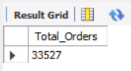

**TOTAL ORDERS KPI - MOM DIFFERENCE AND MOM GROWTH**

SELECT

MONTH(transaction_date) AS month,

ROUND(COUNT(transaction_id)) AS total_orders,

(COUNT(transaction_id) - LAG(COUNT(transaction_id), 1)

OVER (ORDER BY MONTH(transaction_date))) / LAG(COUNT(transaction_id), 1)

OVER (ORDER BY MONTH(transaction_date)) * 100 AS mom_increase_percentage

FROM

coffee_shop_sales

WHERE

MONTH(transaction_date) IN (4, 5) -- for April and May

GROUP BY

MONTH(transaction_date)

ORDER BY

MONTH(transaction_date);

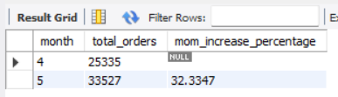

**TOTAL QUANTITY SOLD**

SELECT SUM(transaction_qty) as Total_Quantity_Sold

FROM coffee_shop_sales

WHERE MONTH(transaction_date) = 5 -- for month of (CM-May)

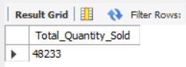

**TOTAL QUANTITY SOLD KPI - MOM DIFFERENCE AND MOM GROWTH**

SELECT

MONTH(transaction_date) AS month,

ROUND(SUM(transaction_qty)) AS total_quantity_sold,

(SUM(transaction_qty) - LAG(SUM(transaction_qty), 1)

OVER (ORDER BY MONTH(transaction_date))) / LAG(SUM(transaction_qty), 1)

OVER (ORDER BY MONTH(transaction_date)) * 100 AS mom_increase_percentage

FROM

coffee_shop_sales

WHERE

MONTH(transaction_date) IN (4, 5) -- for April and May

GROUP BY

MONTH(transaction_date)

ORDER BY

MONTH(transaction_date);

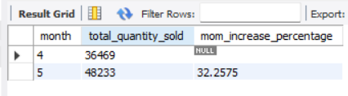

**CALENDAR TABLE – DAILY SALES, QUANTITY and TOTAL ORDERS**

SELECT

SUM(unit_price * transaction_qty) AS total_sales,

SUM(transaction_qty) AS total_quantity_sold,

COUNT(transaction_id) AS total_orders

FROM

coffee_shop_sales

WHERE

transaction_date = '2023-05-18'; --For 18 May 2023

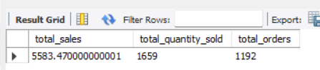

**SALES TREND OVER PERIOD**

SELECT AVG(total_sales) AS average_sales

FROM (

SELECT

SUM(unit_price * transaction_qty) AS total_sales

FROM

coffee_shop_sales

WHERE

MONTH(transaction_date) = 5 -- Filter for May

GROUP BY

transaction_date

) AS internal_query;

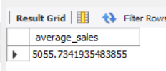

**DAILY SALES FOR MONTH SELECTED**

SELECT

DAY(transaction_date) AS day_of_month,

ROUND(SUM(unit_price * transaction_qty),1) AS total_sales

FROM

coffee_shop_sales

WHERE

MONTH(transaction_date) = 5 -- Filter for May

GROUP BY

DAY(transaction_date)

ORDER BY

DAY(transaction_date);

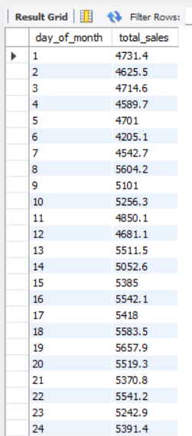 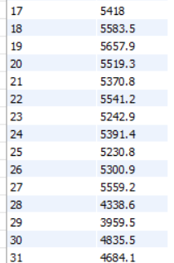

**SALES BY WEEKDAY / WEEKEND:**

SELECT

CASE

WHEN DAYOFWEEK(transaction_date) IN (1, 7) THEN 'Weekends'

ELSE 'Weekdays'

END AS day_type,

ROUND(SUM(unit_price * transaction_qty),2) AS total_sales

FROM

coffee_shop_sales

WHERE

MONTH(transaction_date) = 5 -- Filter for May

GROUP BY

CASE

WHEN DAYOFWEEK(transaction_date) IN (1, 7) THEN 'Weekends'

ELSE 'Weekdays'

END;

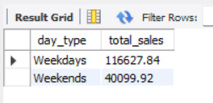

**SALES BY STORE LOCATION**

SELECT

store_location,

SUM(unit_price * transaction_qty) as Total_Sales

FROM coffee_shop_sales

WHERE

MONTH(transaction_date) =5

GROUP BY store_location

ORDER BY SUM(unit_price * transaction_qty) DESC

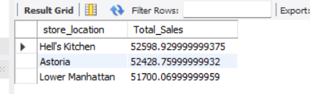

**SALES BY PRODUCT CATEGORY**

SELECT

product_category,

ROUND(SUM(unit_price * transaction_qty),1) as Total_Sales

FROM coffee_shop_sales

WHERE

MONTH(transaction_date) = 5

GROUP BY product_category

ORDER BY SUM(unit_price * transaction_qty) DESC

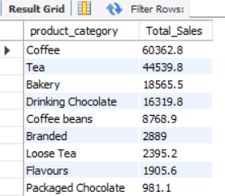

**SALES BY PRODUCTS (TOP 10)**

SELECT

product_type,

ROUND(SUM(unit_price * transaction_qty),1) as Total_Sales

FROM coffee_shop_sales

WHERE

MONTH(transaction_date) = 5

GROUP BY product_type

ORDER BY SUM(unit_price * transaction_qty) DESC

LIMIT 10

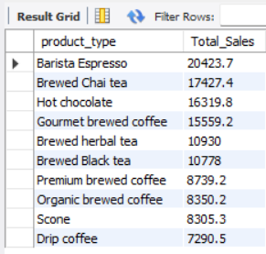

**SALES BY DAY | HOUR**

SELECT

ROUND(SUM(unit_price * transaction_qty)) AS Total_Sales,

SUM(transaction_qty) AS Total_Quantity,

COUNT(*) AS Total_Orders

FROM

coffee_shop_sales

WHERE

DAYOFWEEK(transaction_date) = 3 -- Filter for Tuesday (1 is Sunday, 2 is Monday, ..., 7 is Saturday)

AND HOUR(transaction_time) = 8 -- Filter for hour number 8

AND MONTH(transaction_date) = 5; -- Filter for May (month number 5)

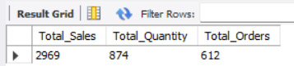

***TO GET SALES FROM MONDAY TO SUNDAY FOR MONTH OF MAY***

SELECT

CASE

WHEN DAYOFWEEK(transaction_date) = 2 THEN 'Monday'

WHEN DAYOFWEEK(transaction_date) = 3 THEN 'Tuesday'

WHEN DAYOFWEEK(transaction_date) = 4 THEN 'Wednesday'

WHEN DAYOFWEEK(transaction_date) = 5 THEN 'Thursday'

WHEN DAYOFWEEK(transaction_date) = 6 THEN 'Friday'

WHEN DAYOFWEEK(transaction_date) = 7 THEN 'Saturday'

ELSE 'Sunday'

END AS Day_of_Week,

ROUND(SUM(unit_price * transaction_qty)) AS Total_Sales

FROM

coffee_shop_sales

WHERE

MONTH(transaction_date) = 5 -- Filter for May (month number 5)

GROUP BY

CASE

WHEN DAYOFWEEK(transaction_date) = 2 THEN 'Monday'

WHEN DAYOFWEEK(transaction_date) = 3 THEN 'Tuesday'

WHEN DAYOFWEEK(transaction_date) = 4 THEN 'Wednesday'

WHEN DAYOFWEEK(transaction_date) = 5 THEN 'Thursday'

WHEN DAYOFWEEK(transaction_date) = 6 THEN 'Friday'

WHEN DAYOFWEEK(transaction_date) = 7 THEN 'Saturday'

ELSE 'Sunday'

END;

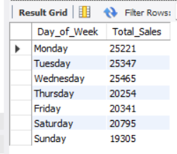

***TO GET SALES FOR ALL HOURS FOR MONTH OF MAY***

SELECT

HOUR(transaction_time) AS Hour_of_Day,

ROUND(SUM(unit_price * transaction_qty)) AS Total_Sales

FROM

coffee_shop_sales

WHERE

MONTH(transaction_date) = 5 -- Filter for May (month number 5)

GROUP BY

HOUR(transaction_time)

ORDER BY

HOUR(transaction_time);

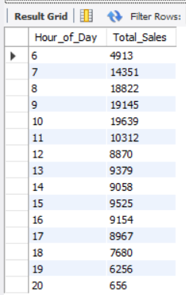

**Data Import in Power BI**

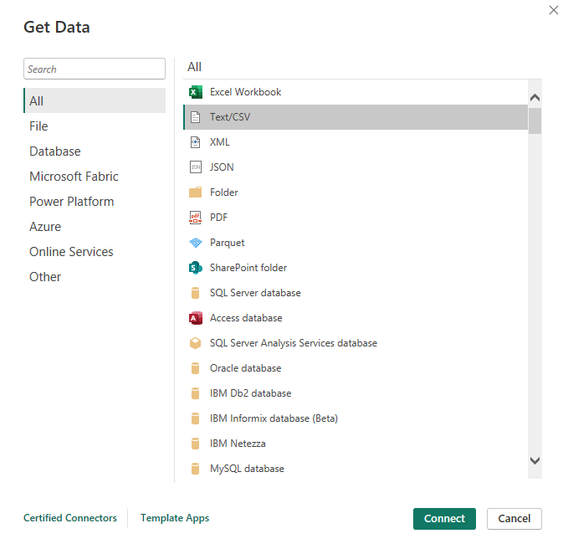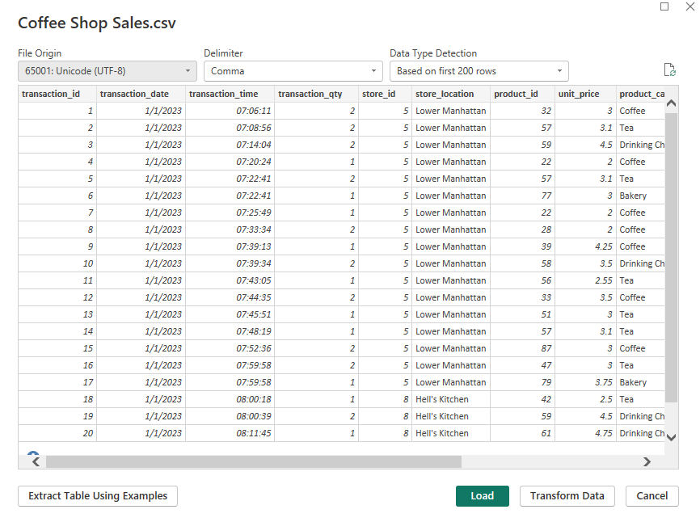

**DATA MODELING**

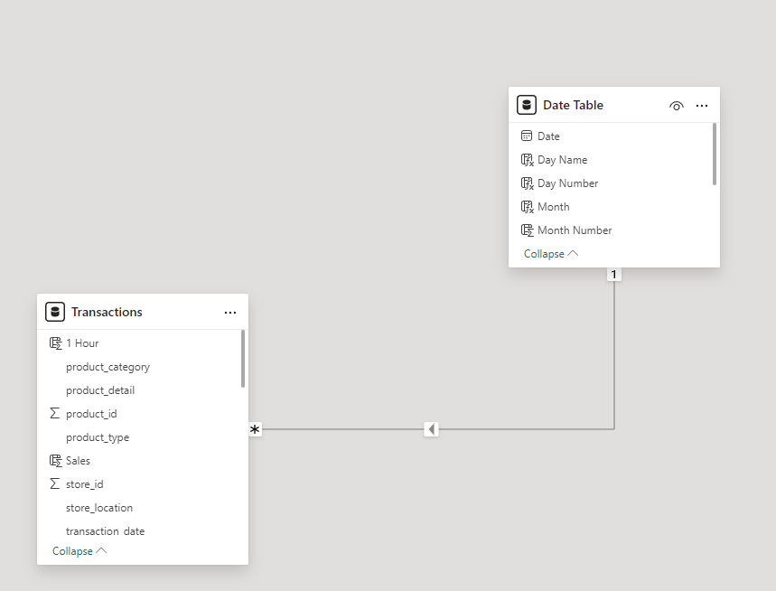

**Build Dashboard or a Report using Power BI**

Created a comprehensive dashboard in Power BI featuring key metrics and charts, including Calendar Heat Map, Sales Analysis by Weekdays and Weekends, Sales Analysis by Store Location, Daily Sales Analysis with Average Line, Sales Analysis by Product Category, Top 10 Products by Sales, Sales Analysis by Days and Hours.

KPI’S

* Total Sales Analysis
* Average Order Analysis
* Total Quantity Sold Analysis

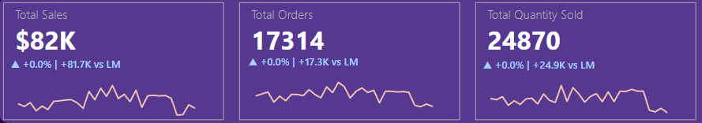

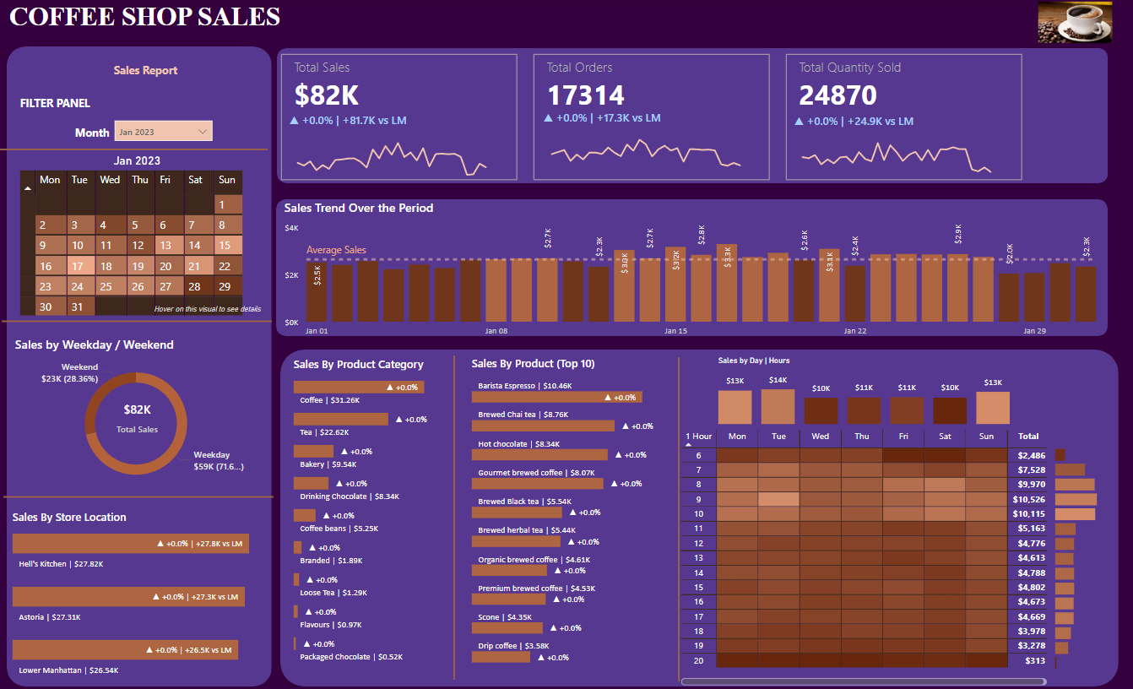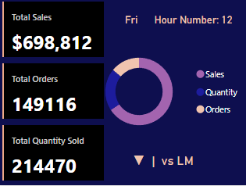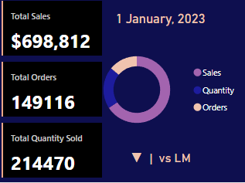

[**Data Analysis and visualization using Jupyter Notebook (Python**](https://github.com/yogeshkasar778/Sales_insights_of_data_analysis-AtliQ_Hardware/edit/main/README.md#data-analysis-using-mysql-) **libraries such as pandas, matplotlib, seaborn, plotly and ipywidgets)**

KPI’S

* Total Sales Analysis
* Average Order Analysis
* Total Quantity Sold Analysis

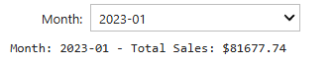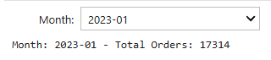

CHARTS

* Total Sales by Store Location (Line Chart)
* Sales Analysis By Product Category (Line Chart)
* Top 10 Products by Sales (Line Chart)

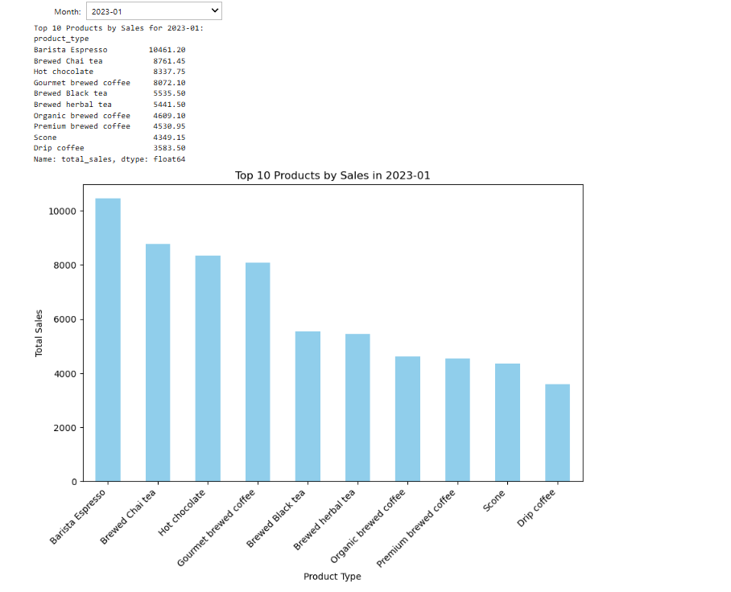

**Tools, Software, and Libraries**

* **MySQL Workbench** **8.0 CE**

for data analysis and storage

* **Power BI Desktop**

for dashboard creation and visualization

* **Jupyter Notebook 7.2.2**

for data analysis and visualization

* **Excel version 2021**  
  for initial data exploration and manipulation

**References**

* <https://www.youtube.com/@datatutorials1>